**EX NO.: 02 DML COMMANDS**

**AIM:**

To work with DML commands

**DML (Data Manipulation Language**):

The DML commands in Structured Query Language change the data present in the SQL database. We can easily access, store, modify, update and delete the existing records from the database using DML commands

**PROCEDURE:**

**Step 1**: Open Run SQL on Command line and connect to SQL

**Step 2:** Then work with database using SQL queries.

**SELECT:**

SELECT is the most important data manipulation command in Structured Query Language. The SELECT command shows the records of the specified table. It also shows the particular record of a particular column by using the WHERE clause.

**Syntax of SELECT DML command**

SELECT column_Name_1, column_Name_2, ….., column_Name_N FROM Name_of_table;

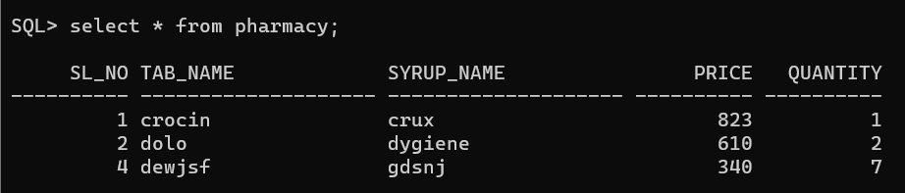**OUTPUT:**

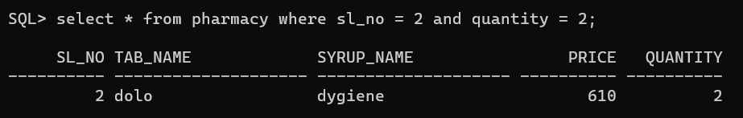**OUTPUT for SELECT using WHERE:**

**INSERT:**

INSERT is another most important data manipulation command in Structured Query Language, which allows users to insert data in database tables.

**Syntax of INSERT Command**

**INSERT** **INTO** TABLE_NAME ( column_Name1 , column_Name2 , column_Name3 , .... column_ NameN )  **VALUES** (value_1, value_2, value_3, .... value_N ) ;

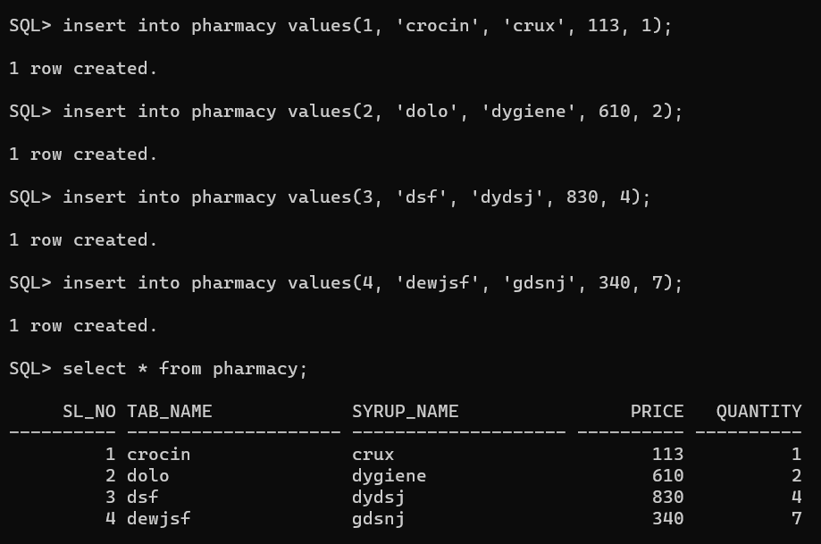**OUTPUT:**

**UPDATE:**

UPDATE is another most important data manipulation command in Structured Query Language, which allows users to update or modify the existing data in database tables.

**Syntax of UPDATE Command**

**UPDATE** Table_name **SET** [column_name1= value_1, ….., column_nameN = value_N]

**WHERE** CONDITION;

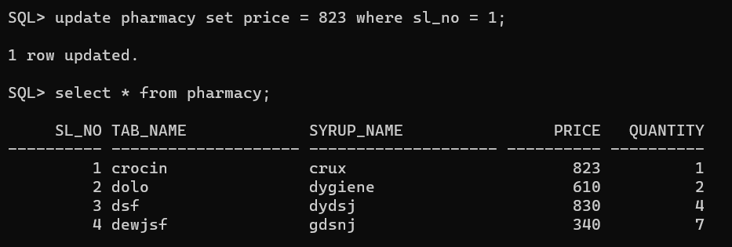**OUTPUT:**

**DELETE:**

DELETE is a DML command which allows SQL users to remove single or multiple existing records from the database tables.

**Syntax of DELETE Command**

**DELETE** **FROM** Table_Name **WHERE** condition;

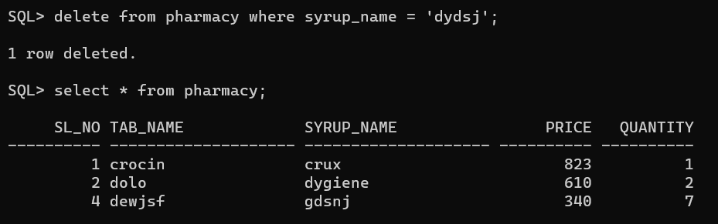**OUTPUT:**